## **Nội dung usecase:**

**Host NIC down làm ảnh hưởng đến VM**

Yêu cầu monitor:

* Trạng thái các interface của Host: up/down
* Kết nối của VM:
  + Ping/curl đến IP của VM. Lưu ý 1 Vm có thể có nhiều IP

Điều kiện alarm

* Alarm 1: Interface của Host down
* Alarm 2: VM bị mất kết nối

Yêu cầu Graph:

* 1 host có thể có nhiều br-ex.
* 1 br-ex có thể nối với 1 hoặc 2 NIC. 1 NIC chỉ nối với 1 br-ex
* 1 br-ex chỉ thuộc 1 provider network

Yêu cầu deduce:

* Deduce stace:
  + Trường hợp 1 br - 1 host NIC: Nếu có alarm 1 => deduce statce của host-NIC, br-ex tương ứng về error và các VM có interfaces nối với network của br-ex đó là ERROR
  + Trường hợp 1 br - 2 host NIC:
    - Nếu có alarm 1 trên 1 NIC => deduce statce của host-NIC, br-ex tương ứng về error và các VM có interfaces nối với network của br-ex đó là WARNING
    - Nếu có alarm 2 trên 1 NIC => deduce statce của host-NIC, br-ex tương ứng về error và các VM có interfaces nối với network của br-ex đó là ERROR
  + Deduce alarm (tương tự deduce stace):
    - Trường hợp 1 br - 1 host NIC: Nếu có alarm 1 => tạo alarm 3 cho VM là bị mất kết nối.
    - Trường hợp 1 br - 2 host NIC:
      * Nếu có alarm 1 trên 1 NIC => tạo alarm 4 cho VM là kết nối bị ảnh hưởng.
      * Nếu có alarm 1 trên 2 NIC => tạo alarm 3 cho VM là bị mất kết nối.

Yêu cầu RCA:

* Tạo RCA Alarm 1 => Alarm 2,|Alarm3|Alarm4

## **Thực hiện:**

### 1. Chuẩn bị monitor các thành phần:

Ở đây cần monitor interface up/down của host và kết nối (ping) đến VM

* Đầu tiên cần cài đặt zabbix agent cho mỗi instance, mỗi host. Các agent này cần gửi thông tin thu thập về cho một zabbix server cài trên 1 host ( hoặc VM), mà host (vm) đó vitrage có thể kết nối được
* Trên UI của zabbix server, ta cấu hình để monitor host và instance như sau:

#### a) Monitor host: interface up/down

* Ứng với mỗi host cần monitor, tạo các zabbix host ứng với các interface host đó: vd host có 5 interface thì tạo 5 zabbix-host

Configuration > host > create host

Hostname: <tên host> port <tên_port> vd “controller port enp4s0f0”

Agent interface: ip của host, mà ip đó dùng kết nối được zabbix server .

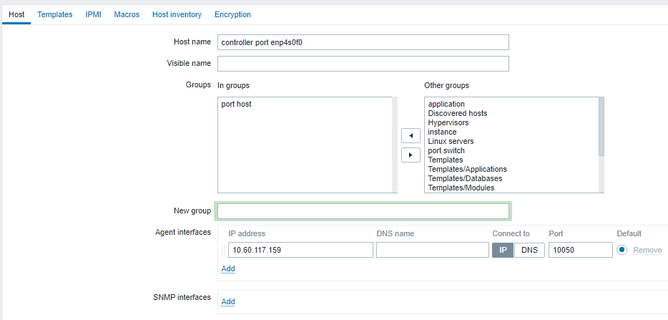

* Tạo item để thu thập thông tin của host:

Vào zabbix UI. tab: Configuration > host > [tên zabbix host] > item > create item

Name: tùy chọn

Key: net.if.link[*] thay * bằng interface muốn monitor

Show value: service state

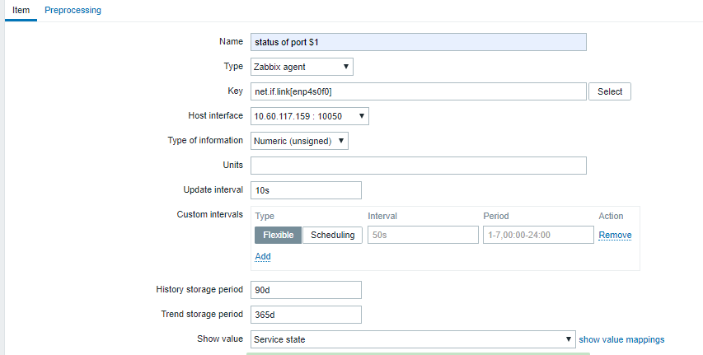

Ở đây, net.if.link là một key ta tự định nghĩa để monitor interface. Tự định nghĩa như sau:

Trên mỗi zabbix agent ,tạo file /etc/zabbix/zabbix_agentd.d/userparameter_niclink.conf nội dung:

|  |
| --- |
| UserParameter=net.if.link[*], if ip a | grep -Eq ": $1:.*state UP" ; then echo "1" ; else echo "0" ; fi |

nếu interface up , item trả về 1(up), nếu không trả về 0(down)

rerstart zabbix-agent.service

* Tạo trigger cảnh báo: khi interface down bắn alarm

Name: interface_down

Key: {controller port enp4s0f0:net.if.link[enp4s0f0].last()}=1

Serverity: high

Allow manual closes.

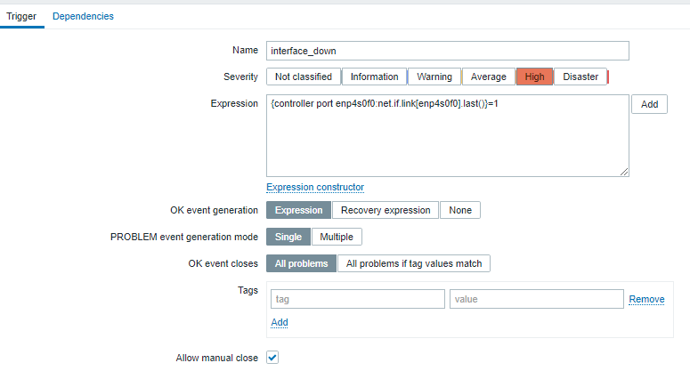

#### **b) Monitor instance** ping kiểm tra kết nối

* Tạo host: ứng với mỗi instance tạo 1 zabbix host:

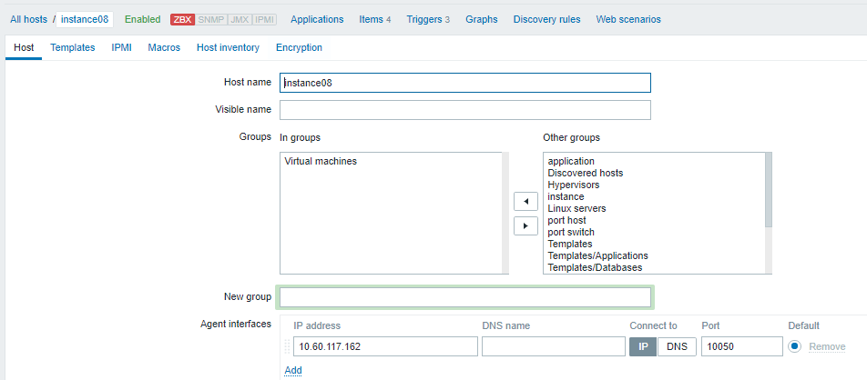

* Tạo item để thu thập thông tin của instance:

Ứng với mỗi ip của instance ta tạo 1 item:

Vào zabbix UI. tab: Configuration > host > [tên zabbix host] > item > create item

Name: ping from zabbix server to $1

Type: simple check

Key: icmpping[*] với * là ip mà ta muốn zabbix server ping tới

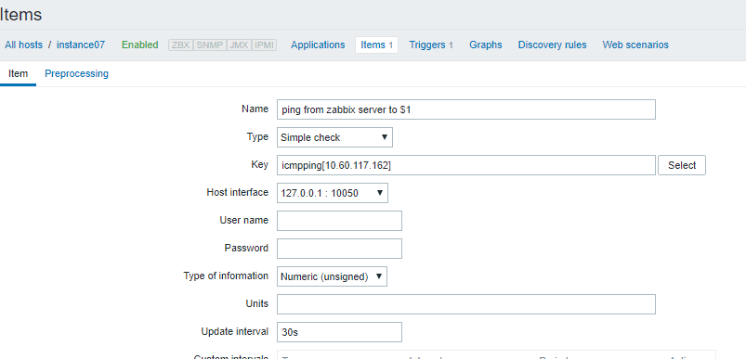

* Tạo trigger cảnh báo :

Expression: dạng:

{<zabbix_host>:icmpping[<ip1>].last()}=0

OR {<zabbix_host>:icmpping[<ip2>].last()}=0

…. với ip1, ip2 là danh sách các ip của instance đó

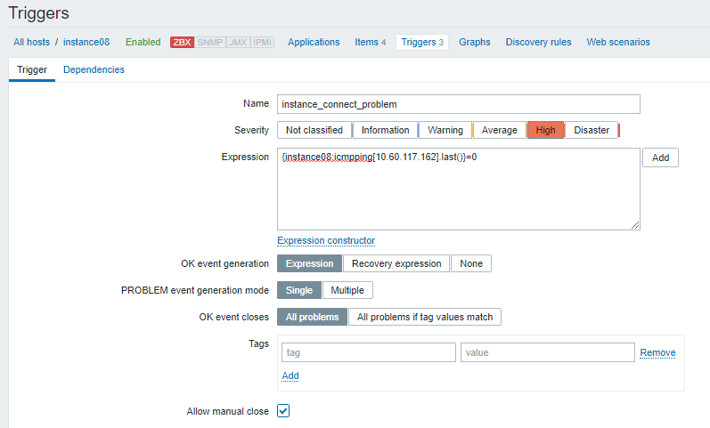

### 2. Chuẩn bị graph

#### a) add static datasoucre:

Mục đích là đưa vào cấu hình các port của host.

Với đề bài:

* 1 host có thể có nhiều br-ex ,
* 1 br-ex có thể nối với 1 hoặc 2 NIC. 1 NIC chỉ nối với 1 br-ex
* 1 br-ex chỉ thuộc 1 provider network

Ví dụ:

* host “controller” có 2 port loại ovs tên “br-provider” và “br-public” 2 port này nối vào 3 nic vật lý : br-provider nối với enp130s0f1, br-public nối với enp130s0f0 và enp130s0f1
* host “compute02” có 2 port ovs tên “br-provider” và “br-public” 2 port nối 2 nic : br-provider nối enp4s0f0 và br-public nối enp103s0f1.

Mô hình ban đầu của vitrage :

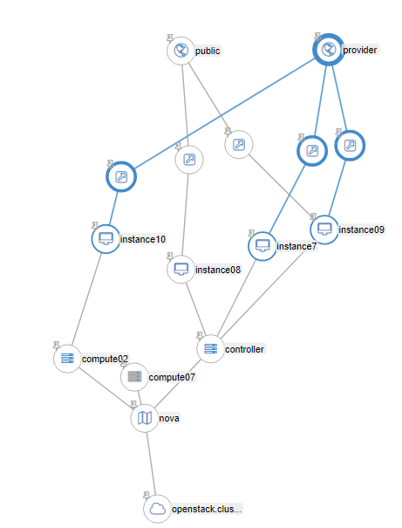

mô hình mong muốn thể hiện:

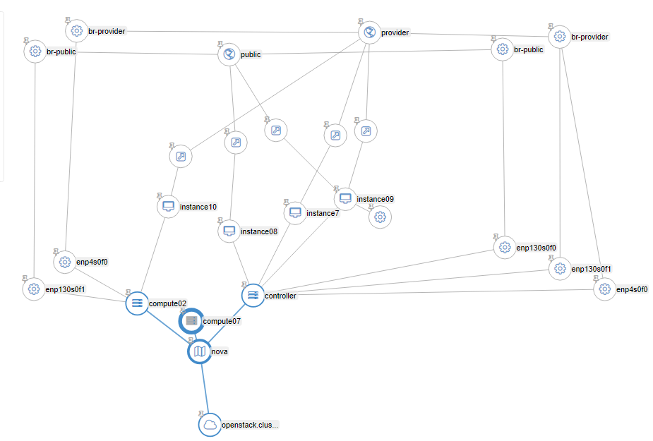

Ta cần thêm các file :

*(để hiểu về nội dung các file cần đọc thêm* [*https://gitlab.visc.com/hoanq13/vitrage-doc/blob/master/entity_graph.md*](https://gitlab.visc.com/hoanq13/vitrage-doc/blob/master/entity_graph.md) *, cách cấu static datasource )*

file thiết lập cho host controller : /etc/vitrage/static_datasources/port_host_controller.yaml

|  |
| --- |
| metadata:  name: port of controller  description: network of controller host  definitions:  entities:  - static_id: br-provider  type: port_ovs  id: controller-port-br-provider  name: br-provider  state: available  - static_id: br-public  type: port_ovs  id: controller-port-br-public  name: br-public  state: available  - static_id: enp4s0f0  type: port_host  id: controller-port-enp4s0f0  name: enp4s0f0  state: available  - static_id: enp130s0f0  type: port_host  id: controller-port-enp130s0f0  name: enp130s0f0  state: available  - static_id: enp130s0f1  type: port_host  id: controller-port-enp130s0f1  name: enp130s0f1  state: available  - static_id: h1  type: nova.host  id: controller  - static_id: provider-network  type: neutron.network  id: 2b0756c1-b74a-4d1f-835c-cc2f66a0bdd3  - static_id: public-network  type: neutron.network  id: 14435664-baec-43ec-93e8-ac30ab916ee7  relationships:  - source: enp4s0f0  target: h1  relationship_type: attached  - source: enp130s0f1  target: h1  relationship_type: attached  - source: enp130s0f0  target: h1  relationship_type: attached  - source: enp4s0f0  target: br-provider  relationship_type: connect  - source: enp130s0f0  target: br-public  relationship_type: connect  - source: enp130s0f1  target: br-provider  relationship_type: connect  - source: br-provider  target: provider-network  relationship_type: attached  - source: br-public  target: public-network  relationship_type: attached |

file thiết lập cho host compute02: /etc/vitrage/static_datasources/port_host_compute02.yaml

|  |
| --- |
| metadata:  name: port of compute02  description: port of compute02  definitions:  entities:  - static_id: br-provider  type: port_ovs  id: compute02-port-br-provider  name: br-provider  state: available  - static_id: br-public  type: port_ovs  id: compute02-port-br-public  name: br-public  state: available  - static_id: enp4s0f0  type: port_host  id: compute02-port-enp4s0f0  name: enp4s0f0  state: available  - static_id: enp130s0f1  type: port_host  id: compute02-port-enp130s0f1  name: enp130s0f1  state: available  - static_id: h1  type: nova.host  id: compute02  # state: AVAILABLE  - static_id: provider-network  type: neutron.network  id: 2b0756c1-b74a-4d1f-835c-cc2f66a0bdd3  state: active  - static_id: public-network  type: neutron.network  id: 14435664-baec-43ec-93e8-ac30ab916ee7  state: active  relationships:  - source: enp4s0f0  target: h1  relationship_type: attached  - source: enp130s0f1  target: h1  relationship_type: attached  - source: enp4s0f0  target: br-provider  relationship_type: connect  - source: enp130s0f1  target: br-public  relationship_type: connect  - source: br-public  target: public-network  relationship_type: attached  - source: br-provider  target: provider-network  relationship_type: attached |

#### b) mapping cho alarm của zabbix vào đồ thị:

Thêm vào file /etc/vitrage/zabbix_conf.yaml

|  |
| --- |
| zabbix:  - zabbix_host: instance07  type: nova.instance  name: eff1daed-0d97-4975-abbd-3d3e907aeedf # (dùng id của instance, không dùng host name)  - zabbix_host: instance08  …  - zabbix_host: controller  type: nova.host  name: controller  - zabbix_host: compute02  type: nova.host  name: compute02 |

Vậy ta đã chuẩn bị xong mô hình input, kết quả:

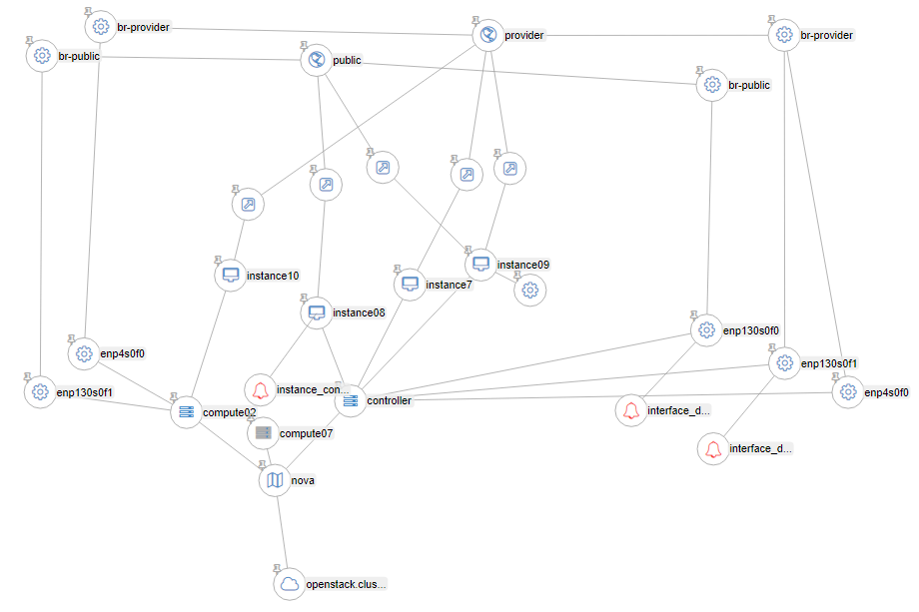

khi zabbix đã bắn 3 alarm : alarm on interface enp130s0f0 và enp13s0f1.

cần vitrage làm :

Warning state trên port br-provider (do port này vẫn còn kết nối được ra ngoài nhờ enp4s0f0) và raise alarm warning instance 07, 09

ERROR state trên port br-public instance08 và raise alarm vitrage trên instance08

### 3. Thêm template:

**Tạo file template /etc/vitrage/templates/usecase4_path1.yaml :**

khi có alarm interface down trên nic deduce alarm “host nic down”

|  |
| --- |
| metadata:  name: deduce-alarm, rca interface down to host nic down and set state error port  description: deduce-alarm rca interface down to host nic down and set state error port  definitions:  entities:  - entity:  category: ALARM  type: zabbix  rawtext: interface_down  template_id: alarm_interface_down  - entity:  category: ALARM  name: host_nic_down  template_id: alarm_port_down  - entity:  category: RESOURCE  type: port_host  template_id: port_host  relationships:  - relationship:  source: alarm_interface_down  target: port_host  relationship_type: on  template_id : alarm_interface_down_on_port  - relationship:  source: alarm_port_down  target: port_host  relationship_type: on  template_id : alarm_port_down_on_port  scenarios:  - scenario:  condition: alarm_interface_down_on_port  actions:  - action:  action_type: set_state  properties:  state: ERROR  action_target:  target: port_host  - action:  action_type: raise_alarm  properties:  alarm_name: host_nic_down  severity: CRITICAL  action_target:  target: port_host  - scenario:  condition: alarm_interface_down_on_port and alarm_port_down_on_port  actions:  - action:  action_type: add_causal_relationship  action_target:  source: alarm_interface_down  target: alarm_port_down |

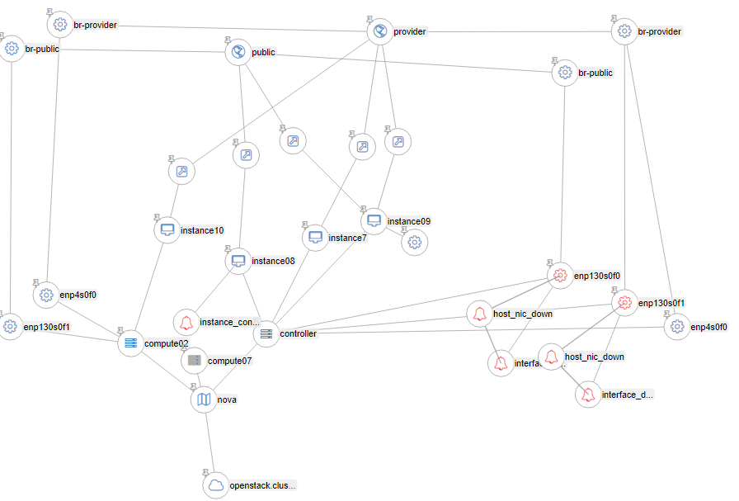

**Tạo file template /etc/vitrage/templates/usecase4_deduce_path2.yaml**

Nhiệm vụ:

Nếu port ovs nối 2 host nic : khi 1 nic down set state warning, 2 nic down set state error

Nếu port ovs chỉ nối 1 host nic: khi 1 nic down set state error

|  |
| --- |
| metadata:  name: deduce-alarm port host down raise alarm and set state on port ovs  description: deduce-alarm port host down raise alarm and set state on port ovs  definitions:  entities:  - entity:  category: ALARM  name: host_nic_down  template_id: alarm_port1_down  - entity:  category: ALARM  name: host_nic_down  template_id: alarm_port2_down  - entity:  category: RESOURCE  type: nova.host  template_id: host  - entity:  category: RESOURCE  type: port_host  template_id: port1_host  - entity:  category: RESOURCE  type: port_host  template_id: port2_host  - entity:  category: RESOURCE  type: port_ovs  template_id: port_ovs  - entity:  category: RESOURCE  type: nova.instance  template_id: instance  relationships:  - relationship:  source: alarm_port1_down  target: port1_host  relationship_type: on  template_id : alarm_on_port1_host  - relationship:  source: alarm_port2_down  target: port2_host  relationship_type: on  template_id : alarm_on_port2_host  - relationship:  source: port1_host  target: host  relationship_type: attached  template_id : port1_host_attached_host  - relationship:  source: port2_host  target: host  relationship_type: attached  template_id : port2_host_attached_host  - relationship:  source: port1_host  target: port_ovs  relationship_type: connect  template_id : port1_host_connect_port_ovs  - relationship:  source: port2_host  target: port_ovs  relationship_type: connect  template_id : port2_host_connect_port_ovs  scenarios:  - scenario:  condition: (alarm_on_port1_host and port1_host_connect_port_ovs and not port2_host_connect_port_ovs) or (alarm_on_port1_host and alarm_on_port2_host and port1_host_connect_port_ovs and port2_host_connect_port_ovs)  actions:  - action:  action_type: set_state  properties:  state: ERROR  action_target:  target: port_ovs  - scenario:  condition: alarm_on_port1_host and not alarm_on_port2_host and port1_host_connect_port_ovs and port2_host_connect_port_ovs  actions:  - action:  action_type: set_state  properties:  state: SUBOPTIMAL  action_target:  target: port_ovs |

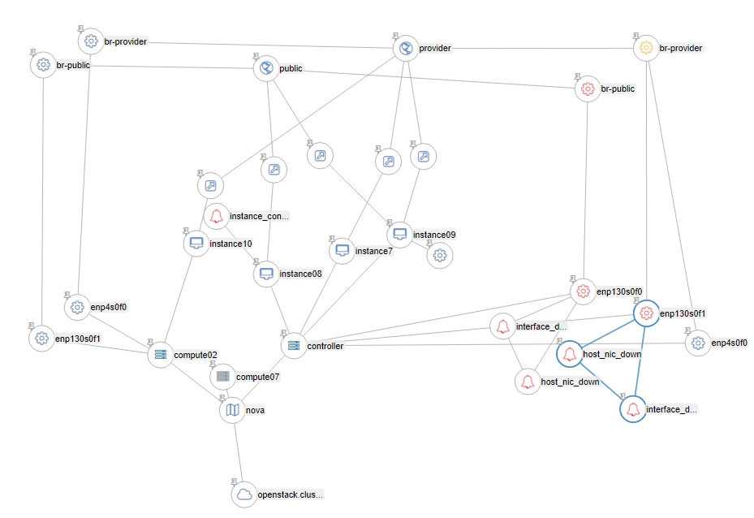

**Tạo file template /etc/vitrage/templates/usecase4_deduce_path3-1.yaml**

Nhiệm vụ: nếu port ovs bị warning thì set state, bật alarm warning trên instance ảnh hưởng

|  |
| --- |
| metadata:  name: deduce-alarm port host down and port ovs suboptimal raise alarm and set state on instance, host, neutron port  description: deduce-alarm port host down and port ovs suboptimal raise alarm and set state on instance, host, neutron port  definitions:  entities:  - entity:  category: ALARM  name: host_nic_down  template_id: alarm_port_down  - entity:  category: RESOURCE  type: port_host  template_id: port_host  - entity:  category: RESOURCE  type: port_ovs  vitrage_operational_state: SUBOPTIMAL  template_id: port_ovs_warning  - entity:  category: RESOURCE  type: nova.instance  template_id: instance  - entity:  category: RESOURCE  type: nova.host  template_id: host  - entity:  category: RESOURCE  type: neutron.network  template_id: neutron_network  - entity:  category: RESOURCE  type: neutron.port  template_id: port_neutron  relationships:  - relationship:  source: alarm_port_down  target: port_host  relationship_type: on  template_id : alarm_on_port_host  - relationship:  source: port_host  target: host  relationship_type: attached  template_id : port_host_attached_host  - relationship:  source: port_host  target: port_ovs_warning  relationship_type: connect  template_id : port_host_connect_port_ovs  - relationship:  source: port_ovs_warning  target: neutron_network  relationship_type: attached  template_id : port_ovs_attached_network  - relationship:  source: neutron_network  target: port_neutron  relationship_type: contains  template_id : network_contains_neutron_port  - relationship:  source: port_neutron  target: instance  relationship_type: attached  template_id : port_neutron_attached_instance  - relationship:  source: host  target: instance  relationship_type: contains  template_id : host_contains_instance  scenarios:  - scenario:  condition: (port_ovs_warning and port_ovs_attached_network and network_contains_neutron_port and port_neutron_attached_instance) and (alarm_on_port_host and port_host_attached_host and host_contains_instance ) and port_host_connect_port_ovs  actions:  - action:  action_type: set_state  properties:  state: SUBOPTIMAL  action_target:  target: neutron_network  - action:  action_type: set_state  properties:  state: SUBOPTIMAL  action_target:  target: port_neutron  - action:  action_type: set_state  properties:  state: SUBOPTIMAL  action_target:  target: instance  - action:  action_type: raise_alarm  properties:  alarm_name: instance_connect_at_risk  severity: WARNING  action_target:  target: instance |

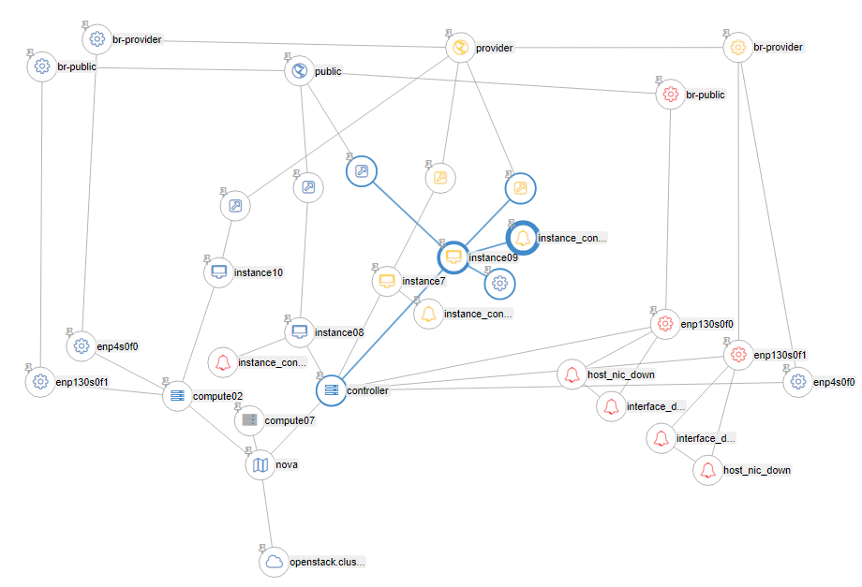

**Tạo file template /etc/vitrage/templates/usecase4_deduce_path3-2.yaml**

Nhiệm vụ: nếu port ovs bị error thì set state, bật alarm critical trên instance ảnh hưởng

|  |
| --- |
| metadata:  name: deduce-alarm port host down and port ovs error raise alarm and set state on instance, host, neutron port  description: deduce-alarm port host down and port ovs error raise alarm and set state on instance, host, neutron port  definitions:  entities:  - entity:  category: ALARM  name: host_nic_down  template_id: alarm_port_down  - entity:  category: RESOURCE  type: port_host  template_id: port_host  - entity:  category: RESOURCE  type: port_ovs  vitrage_operational_state: ERROR  template_id: port_ovs_error  - entity:  category: RESOURCE  type: nova.instance  template_id: instance  - entity:  category: RESOURCE  type: nova.host  template_id: host  - entity:  category: RESOURCE  type: neutron.network  template_id: neutron_network  - entity:  category: RESOURCE  type: neutron.port  template_id: port_neutron  relationships:  - relationship:  source: alarm_port_down  target: port_host  relationship_type: on  template_id : alarm_on_port_host  - relationship:  source: port_host  target: host  relationship_type: attached  template_id : port_host_attached_host  - relationship:  source: port_host  target: port_ovs_error  relationship_type: connect  template_id : port_host_connect_port_ovs  - relationship:  source: port_ovs_error  target: neutron_network  relationship_type: attached  template_id : port_ovs_attached_network  - relationship:  source: neutron_network  target: port_neutron  relationship_type: contains  template_id : network_contains_neutron_port  - relationship:  source: port_neutron  target: instance  relationship_type: attached  template_id : port_neutron_attached_instance  - relationship:  source: host  target: instance  relationship_type: contains  template_id : host_contains_instance  scenarios:  - scenario:  condition: (port_ovs_error and port_ovs_attached_network and network_contains_neutron_port and port_neutron_attached_instance) and (alarm_on_port_host and port_host_attached_host and host_contains_instance ) and port_host_connect_port_ovs  actions:  - action:  action_type: set_state  properties:  state: ERROR  action_target:  target: neutron_network  - action:  action_type: set_state  properties:  state: ERROR  action_target:  target: port_neutron  - action:  action_type: set_state  properties:  state: ERROR  action_target:  target: instance  - action:  action_type: raise_alarm  properties:  alarm_name: instance_connect_problem  severity: CRITICAL  action_target:  target: instance |

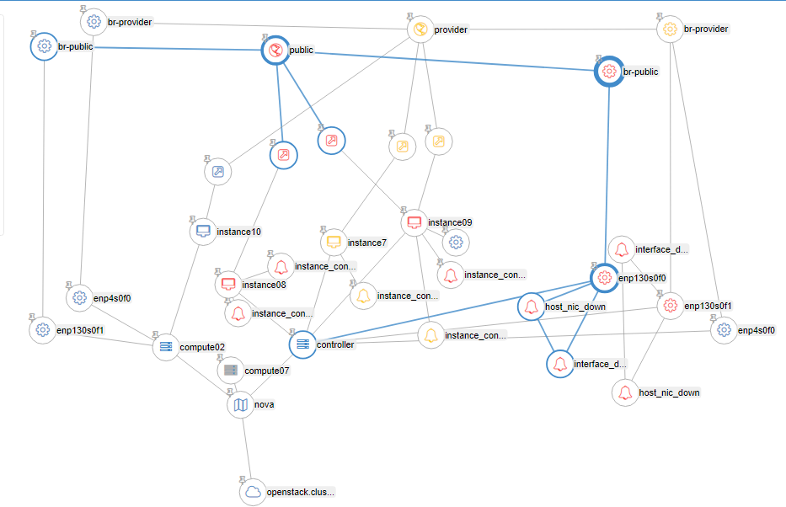

Thêm các file để rca các alarm deduce , alaem zabbix

usecase4_rca_error_alarm.yaml:

|  |
| --- |
| metadata:  name: rca alarm error on instance caused by alarm error on port_host  description: rca alarm error on instance caused by alarm error on port_host  definitions:  entities:  - entity:  category: ALARM  name: instance_connect_problem  template_id: alarm_instance_connect_problem  - entity:  category: RESOURCE  type: nova.instance  template_id: instance  - entity:  category: RESOURCE  type: neutron.port  vitrage_operational_state: ERROR  template_id: port_neutron  - entity:  category: RESOURCE  type: neutron.network  vitrage_operational_state: ERROR  template_id: neutron_network  - entity:  category: RESOURCE  type: port_ovs  vitrage_operational_state: ERROR  template_id: port_ovs  - entity:  category: RESOURCE  type: port_host  vitrage_operational_state: ERROR  template_id: port_host  - entity:  category: ALARM  name: host_nic_down  template_id: alarm_port_host_down  - entity:  category: RESOURCE  type: nova.host  template_id: host  relationships:  - relationship:  source: alarm_instance_connect_problem  target: instance  relationship_type: on  template_id : alarm_on_instance  - relationship:  source: port_neutron  target: instance  relationship_type: attached  template_id : port_neutron_attached_instance  - relationship:  source: neutron_network  target: port_neutron  relationship_type: contains  template_id : network_contains_neutron_port  - relationship:  source: port_ovs  target: neutron_network  relationship_type: attached  template_id : port_ovs_attached_network  - relationship:  source: port_host  target: port_ovs  relationship_type: connect  template_id : port_host_connect_port_ovs  - relationship:  source: host  target: instance  relationship_type: contains  template_id : host_contains_instance  - relationship:  source: port_host  target: host  relationship_type: attached  template_id : port_host_attached_host  - relationship:  source: alarm_port_host_down  target: port_host  relationship_type: on  template_id : alarm_on_port_host  scenarios:  - scenario:  condition: alarm_on_instance and (port_neutron_attached_instance and network_contains_neutron_port and port_ovs_attached_network and port_host_connect_port_ovs and port_host_connect_port_ovs ) and (host_contains_instance and port_host_attached_host) and alarm_on_port_host  actions:  - action:  action_type: add_causal_relationship  action_target:  source: alarm_port_host_down  target: alarm_instance_connect_problem |

usecase4_rca_warning_alarm.yaml

|  |
| --- |
| metadata:  name: rca alarm warning on instance caused by alarm error on port_host  description: rca alarm warning on instance caused by alarm error on port_host  definitions:  entities:  - entity:  category: ALARM  name: instance_connect_at_risk  template_id: alarm_instance_connect_at_risk  - entity:  category: RESOURCE  type: nova.instance  template_id: instance  - entity:  category: RESOURCE  type: neutron.port  vitrage_operational_state: SUBOPTIMAL  template_id: port_neutron  - entity:  category: RESOURCE  type: neutron.network  vitrage_operational_state: SUBOPTIMAL  template_id: neutron_network  - entity:  category: RESOURCE  type: port_ovs  vitrage_operational_state: SUBOPTIMAL  template_id: port_ovs  - entity:  category: RESOURCE  type: port_host  vitrage_operational_state: ERROR  template_id: port_host  - entity:  category: ALARM  name: host_nic_down  template_id: alarm_port_host_down  - entity:  category: RESOURCE  type: nova.host  template_id: host  relationships:  - relationship:  source: alarm_instance_connect_at_risk  target: instance  relationship_type: on  template_id : alarm_on_instance  - relationship:  source: port_neutron  target: instance  relationship_type: attached  template_id : port_neutron_attached_instance  - relationship:  source: neutron_network  target: port_neutron  relationship_type: contains  template_id : network_contains_neutron_port  - relationship:  source: port_ovs  target: neutron_network  relationship_type: attached  template_id : port_ovs_attached_network  - relationship:  source: port_host  target: port_ovs  relationship_type: connect  template_id : port_host_connect_port_ovs  - relationship:  source: host  target: instance  relationship_type: contains  template_id : host_contains_instance  - relationship:  source: port_host  target: host  relationship_type: attached  template_id : port_host_attached_host  - relationship:  source: alarm_port_host_down  target: port_host  relationship_type: on  template_id : alarm_on_port_host  scenarios:  - scenario:  condition: alarm_on_instance and (port_neutron_attached_instance and network_contains_neutron_port and port_ovs_attached_network and port_host_connect_port_ovs and port_host_connect_port_ovs ) and (host_contains_instance and port_host_attached_host) and alarm_on_port_host  actions:  - action:  action_type: add_causal_relationship  action_target:  source: alarm_port_host_down  target: alarm_instance_connect_at_risk |



    
    
    